Centre for Indigenous Environmental Resources,
Environment and Climate Change Canada/Canadian Wildlife Service,
& Drawing Change

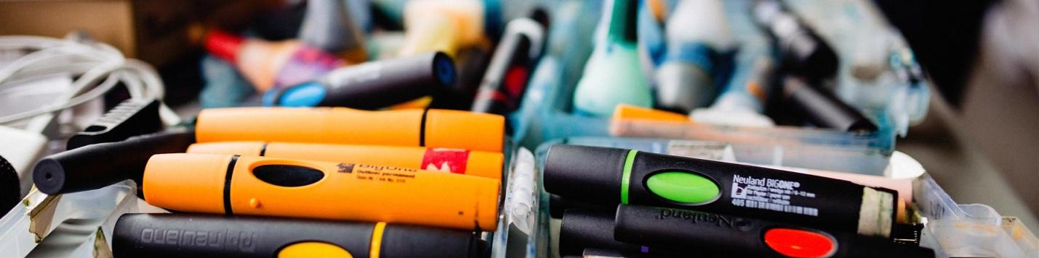

Application for FREE Graphic Recording Training Program

This training is being offered by The Centre for Indigenous Environmental Resources (CIER) and Drawing Change, and is funded by Environment and Climate Change Canada – Canadian Wildlife Service (ECCC-CWS), through the Species at Risk Act Consultation, Cooperation and Accommodation (SARA-CCA) project. The SARA-CCA project is offering the training to support its work on species at risk.

To apply, please provide the items below to Rachel at rcharette@yourcier.org by 5pm local time on June 27th, 2024. CIER, ECCC-CWS, and Drawing Change will review the materials submitted and will inform successful applicants by July 11, 2024.

Please include the following in your application:

- Contact information
- The form below, to share your communication skills and why you are interested in this opportunity
- We would love to see an example of how you are creative (e.g., music, art, photos, video, writing). This is a training that emphasizes drawing, but we know people are creative in many ways
- A short email or letter of support from an agency or employer where you could practice your skills after the training.

Contact Information:
Name of Community or Organization
Applicant’s Name
Applicant’s Role in community or organization
Applicant’s Email
Applicant’s Phone Number
Shipping Address, City, Province/Territory & Postal Code for mailing supplies to the participant – if this is different than the organization/ community

Why do you want to participate in this Graphic Recording Training Program?

Check List for Participants
- I can attend all 5 online training sessions listed in the schedule.
- I can attend at least one of the species at risk workshops that CIER organizes and facilitates to practice the skills I have learned.
- I would be interested in ECCC-CWS and CIER contacting me regarding potential opportunities to provide graphic recording services following completion of the program.
- I know that no one is expecting me to be perfect and art is messy and that we are all learning together.
- Especially for Youth: I will try to provide my graphic recording skills to my community to the best of my ability!
- For any Mentors who are helping someone apply: I will try to support _____________ and seek opportunities for them to practice their graphic recording skills in my community or organization to the best of my ability.

Signature Date

_____________________________________________________________________

*We thank all those who apply for this training program and have only a limited number of seats. CIER, ECCC and Drawing Change will review and select participants. All candidates will be notified about whether they are accepted into the program.

