Species at Risk Act (SARA) Consultation, Cooperation and Accommodation Project

SARA101 Session Report
September 29, 2022

Created by:
The Centre for Indigenous Environmental Resources (CIER)

Acknowledgments
The Centre for Indigenous Environmental Resources (CIER) and Environment and Climate Change Canada – Canadian Wildlife Services (ECCC-CWS) would like to thank the participants that attended the virtual “Species at Risk Act (SARA) Consultation, Cooperation, and Accommodation Project (SARA-CCA)” workshops.

Contents

Acknowledgments 2
Contents 2
Introduction 3
SARA101 Session Agenda 3
Presentation Overview 4
Discussion Summary 5
Navigating the Species at Risk Act and Listing Process – Victoria Leck 5
Recovery Planning 6
Funding 7
Discussion Question 8
Current Listing Consultation – Kate O’Donoghue 8
Navigating the Species at Risk Public Registry – Christine Roche 8
Capacity Funding – Application and Reporting – Lynn Mallett 8
Detailed Discussions 9
Appendix A – Participant contact information 10

Introduction
This multi-year project will facilitate Indigenous communities’ and organizations’ participation in ECCC’s listing and recovery planning processes for terrestrial species, as part of implementing the Federal Species at Risk Act (SARA). Each region will focus their resources on an area of study and development that maximizes efforts to each species (see regional lists posted on CIER’s websites respective provincial pages: https://yourcier.org/sara/ontario/).
The goals of the SARA project are to:
- Support capacity and skills development to incorporate Species at Risk and SARA considerations in land use planning, management, and stewardship. ​
- Enhance opportunities to contribute meaningfully to listing and recovery planning under SARA for terrestrial Species at Risk – including capacity funding. ​
- Provide funding for targeted recovery actions focused on priority species in the SARA legislated framework for this year and next.

CIER’s role is to provide support in an administrative capacity to Indigenous communities, and organizations, and ECCC in their collaborative work including developing recovery documents, sharing knowledge and language, addressing threats to terrestrial species at risk survival and recovery, and land use planning for species at risk on reserve lands and within traditional territories. CIER also manages the provision of funds on behalf of ECCC for SARA participation, funding requests and EOI’s.
Depending on the region, key project components will include Information sharing sessions as follows:
- Engagement workshops
- Nation-to-nation dialogues
- Training sessions
- Modest capacity funding
- Project evaluation and reporting

SARA101 Session Agenda
Time (EST) | Agenda Item & Who | Notes
9:00-9:15 | Welcome, Acknowledgment and Introduction | CIER – Lynn Mallett
9:15 – 10:30 | Overview of Species at Risk Act | ECCC - Victoria Leck
10:30-10:45 | Break (15 mins) | Break and Discussion Questions (Provided ahead of time so participants can think about them)
10:45-11:00 | Current Listing Consultations | ECCC - Kate O’Donoghue
11:00-11:15 | Navigating the Species at Risk Public Registry | ECCC - Christina Rohe
11:15-11:30 | Capacity Funding – Application and Reporting | CIER – Lynn Mallett
11:30-11:40 | Closing and Wrap-Up | ECCC - Christina Rohe;  ECCC - CIER

Presentation Overview
As part of the project, CIER facilitated a SARA101 Session on September 29, 2022. This session provided an introductory overview of SARA, and the process of assessing, listing, recovery planning and implementation of species at risk protections. Current regional terrestrial species undergoing listing consultation and recovery planning within the next two years as part of the SARA Consultation, Cooperation and Accommodation Project was also presented, as well as Navigating the Species at Risk Public Registry. An overview of the Capacity Funding application and reporting was also provided.
- SARA Overview was presented by Victoria Leck, Canadian Wildlife Service (CWS) under Environment Climate Change Canada (ECCC).
- Current Listing Consultations was presented by Kate O’Donoghue, Canadian Wildlife Service (CWS) under Environment Climate Change Canada (ECCC).
- Navigating the Species at Risk Public Registry was presented by Christina Rohe, Canadian Wildlife Service (CWS) under Environment Climate Change Canada (ECCC).
- Capacity Funding – application and reporting was presented by Lynn Mallett, Canadian Indigenous Environmental Resources (CIER).
In attendance at the workshop were 13 participants from 13 Indigenous organizations and communities. A polling question asked participants to state which community or territory they were from, the results of which are below.
Figure 1: Please tell us what community or territory you are from?
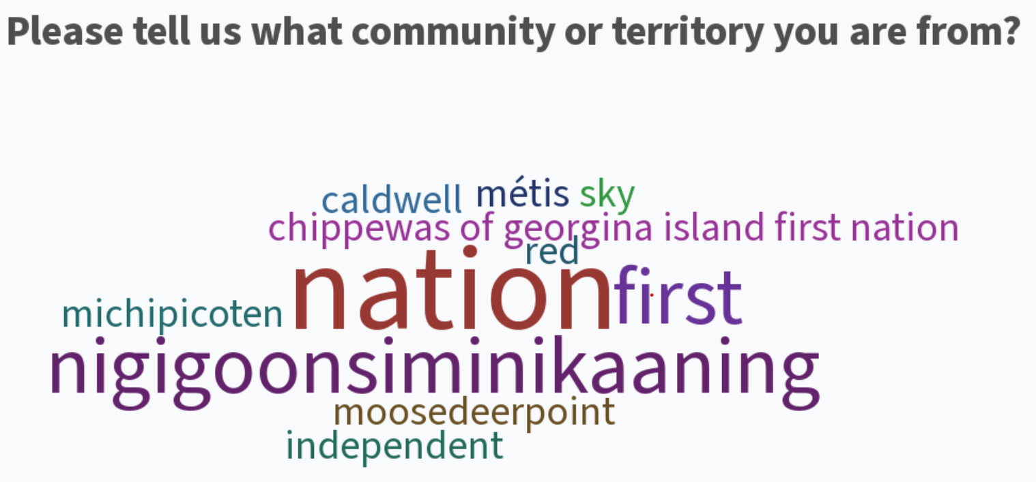

SARA is designed to protect individuals and habitat, allow for recovery of species, and work in a complementary fashion with provincial legislation. The Species at Risk Act Process can be found in the following figure and is adapted from ECCC SARA101 presentation by Victoria Leck.
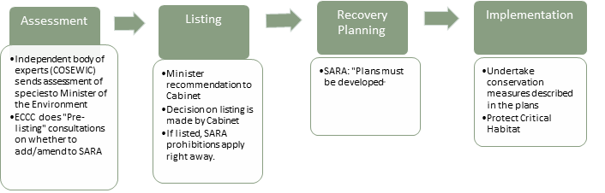

Discussion Summary

Navigating the Species at Risk Act and Listing Process – Victoria Leck
The first part of the presentation provided an overview of SARA and the listing processes. Following this part of the session a polling question was asked to the participants. The results for the first polling question are as follows.

Figure 2: Has you or your community been involved in providing comments of a proposed species listing? 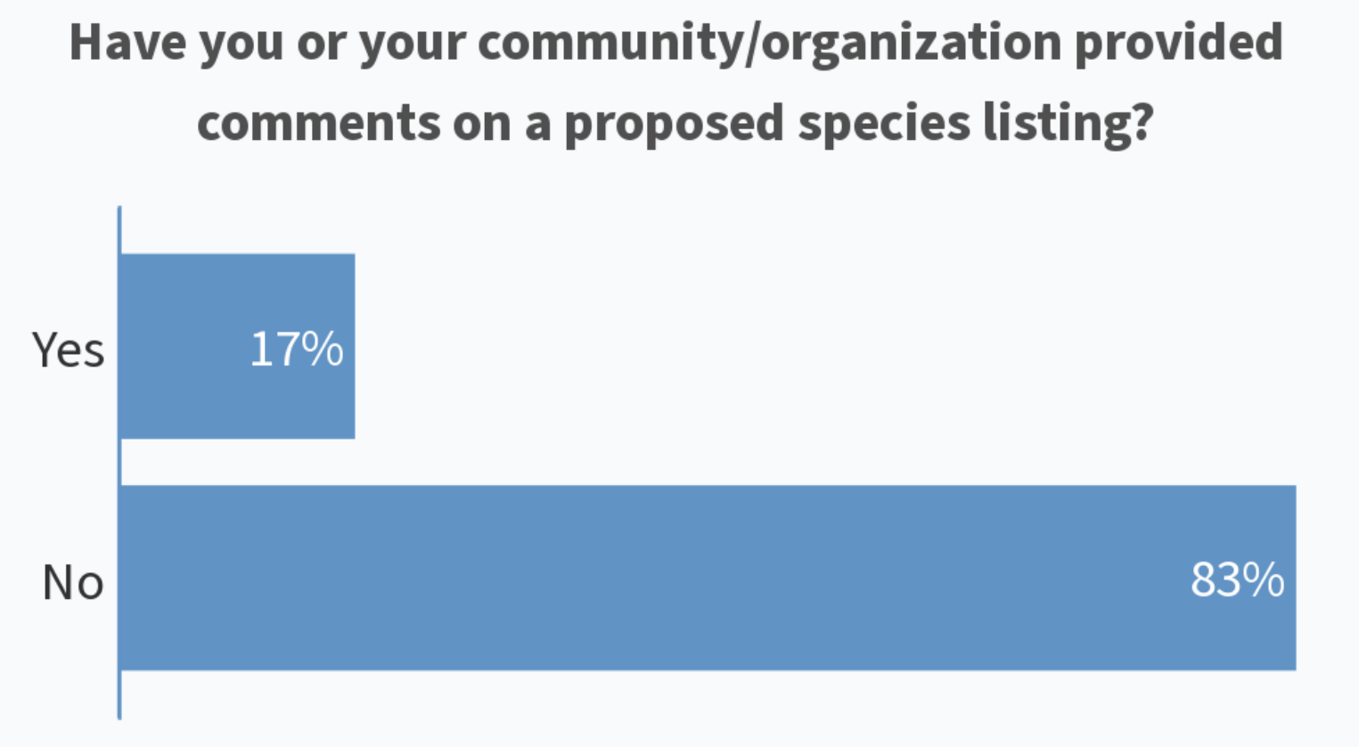

Recovery Planning
The presentation then moved on to provide an overview of the recovery planning process. Following this portion of the presentation, the participants were asked a polling question. The results of the second polling questions are as follows.

Figure 3: Have you or your community/organization provided input and/or advice on Recovery Documents?:
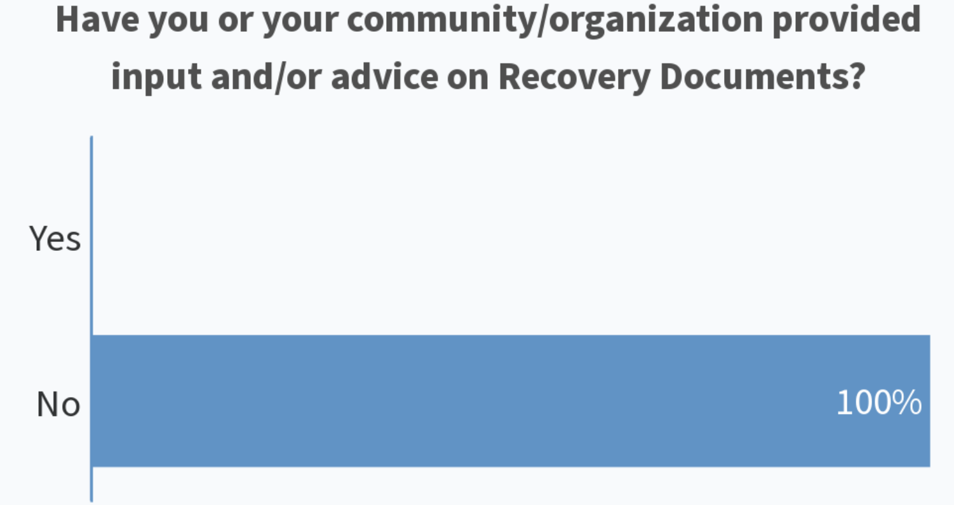

Funding
An overview of the funding of actions identified in recovery strategies and management plans was provided. Funding includes the Aboriginal Fund for the Species at Risk (AFSAR) / Habitat Stewardship Program (HSP). Capacity funding, participant fees and honoraria for workshops through SARA-CCA partnership with CIER were also mentioned (which is discussed in more detail later in the presentation). The third polling question focused on AFSAR and HSP funding and the results of the third polling questions are as follows.
Figure 4: Have you or your community/organization been involved with any AFSAR or HSP projects?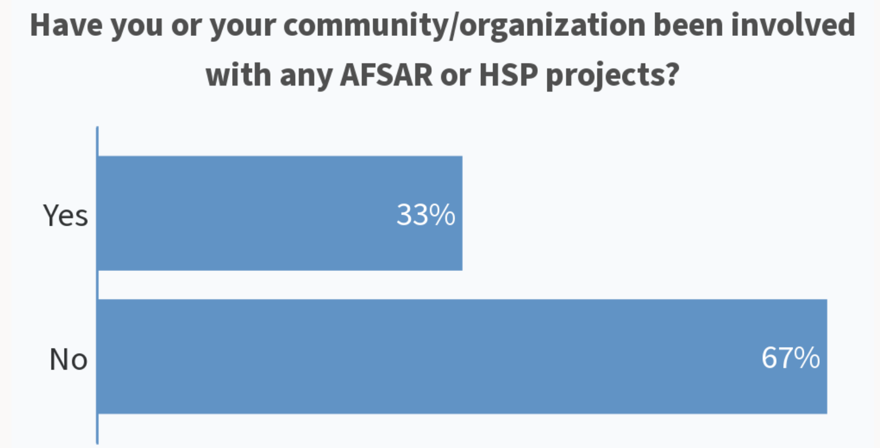

Discussion Question
The following discussion questions were posted during the break for participants to consider:
Q1. How can we improve cooperation and participation in the Species at Risk Act process?
- What are the barriers that prevent participation?​
- What works well with the current process
- What doesn’t work?​
- What can we do to improve listing and recovery document consultations?​
​

Current Listing Consultation – Kate O’Donoghue
An overview was provided of the current listing consultations, as well as anticipated listing consultations that will be coming up in early 2023. A list of the upcoming recovery document consultations was also provided. A fourth polling question asked participants to add to a word cloud topic on what at-risk species would they like to have more engagement and cooperation on, the results of which are as follows.

Figure 5: What at-risk species would you and/or your community like to have more engagement and cooperation on?
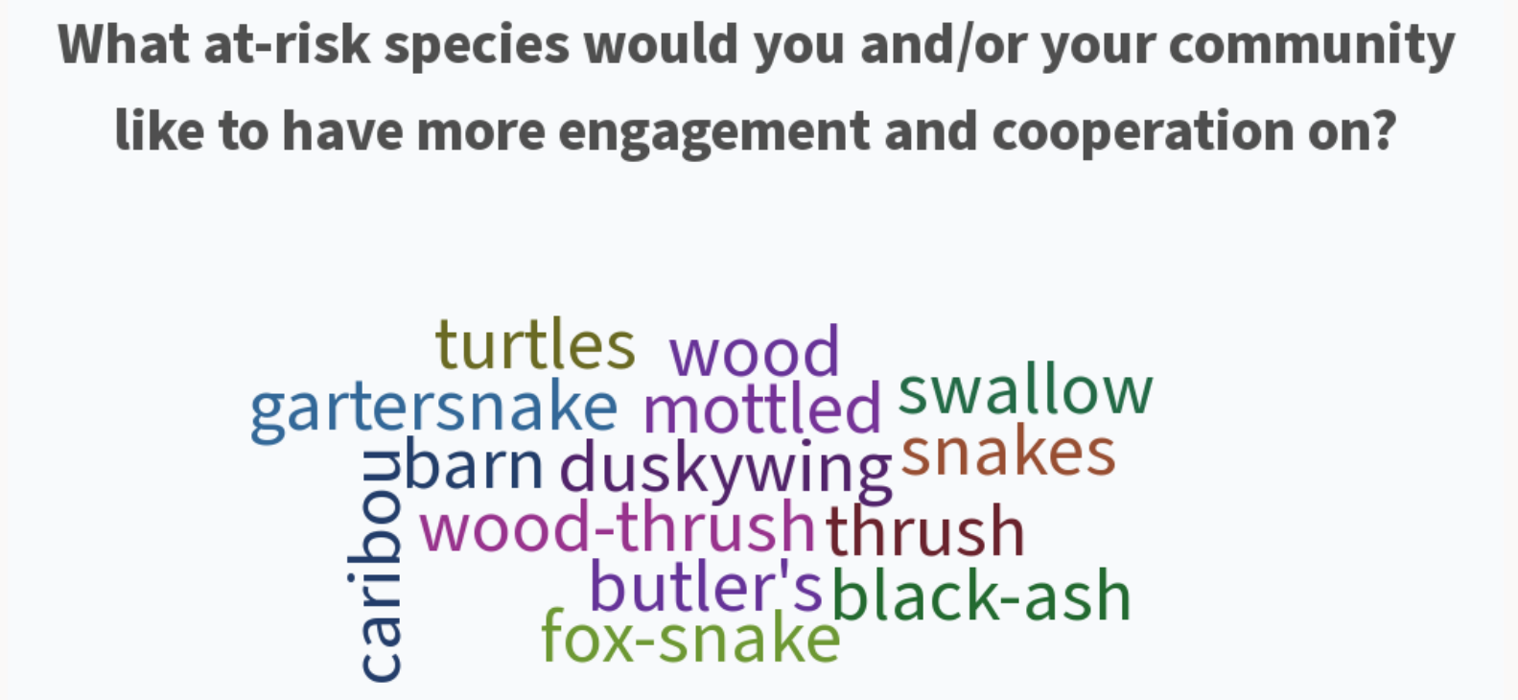

Navigating the Species at Risk Public Registry –Christina Rohe
Participants were shown how to navigate the registry website, how to do searches, how to use the filters, where to find recovery documents, COSEWIC status reports, and information on the species themselves.

Capacity Funding – Application and Reporting – Lynn Mallett
An overview of funding available under SARA-CCA was provided: 1) Participant fees can be covered through CIER when attending workshops provided by ECCC; and, 2) Capacity requests through CIER to support information sharing. For capacity requests, the participants were shown the CIER website and how to find the application form, how to fill in the form, and reporting requirements.

Detailed Discussions
Question/Comment: Participant asked for examples of possible socioeconomic impacts or benefit to listing or not listing a species.

ECCC (Victoria Leck): Some examples are if the species provides environmental benefits such as pollination, pest control, flood control, etc. it could impact the listing. If a species provides cultural or spiritual benefits such as recreation, sense of place or tradition there can be qualitative or quantitative impacts. If a species is important for tourism in the area it may be a benefit to list the species to ensure it is still there. There are also economic impacts in the costs to eradicate invasive species or to apply for a permit or to undertake mitigation efforts to protect a species.

Question/Comment: Participant points out that the issue is always lack of capacity because no long-term funding, explaining further that its hard to drum up community interest as if each species was not part of everything else.

ECCC (Victoria Leck): We have heard this before and while we cannot address the long-term funding issue we can help with some capacity building for communities.

Question/Comment: Participant would like to be sent out a listing package.

ECCC (Kate O’Donoghue): We can send a listing package if we can get your contact information (Contact information received and package was sent following the workshop).

Question/Comment: Participant commented that it is hard to know species by name and that it would be helpful if there was also a picture of the species so that people could see and recognize it.

ECCC (Christina Rohe): Good suggestion, okay we will add more pictures to our slides moving forward.

Question/Comment: Participant was interested in refining searches on the SAR Registry and asked if the range filters could be scaled down further or is Ontario the smallest option to filter in this region.

ECCC (Christina Rohe): Yes, Ontario is the smallest option to narrow the filter for this region on the SAR Public Registry. We can help develop a list of potential / likely SAR in your area of interest (list of SAR was sent to participant following the workshop). Kate O’Donoghue also suggested some options using the NHIC ‘Make a Map’ tool.

